26 June 2012

To: ALL COUNTY AND REGIONAL SCHOOLS’ FA SECRETARIES

Dear Secretary,

Disciplinary Procedures for Season 2012-2013

The English Schools’ FA Council has decided that from the start of Season 2012-2013, ALL levels of School Football will be included in ONE category (i.e. Inter-School, Inter-District, Inter-County and International) and will mirror The Football Association’s models in other categories - suspensions issued will be MATCH BASED (competition matches only).

Council acknowledges that in some areas and in some schools there may be a long time lapse between competition games, therefore, if 6 months elapse before the required number of matches from which a player is suspended, then the suspension will be deemed to have finished (the 6 month period does not include June, July and August). In the majority of cases suspensions will end quickly.

Council is offering County Schools’ FAs the opportunity to have School Football discipline centrally managed by HQ in Stafford or for them to continue to manage their own discipline if they so wish.

Your County SFA must inform ESFA as to whether or not you intend to opt in/out of this system and must supply information regarding your County SFA discipline record from last season to ESFA by no later than 20 July 2012 (complete attached form). ESFA will inform The FA which Counties are ‘in’ or ‘out’ and this information will also be published in the ESFA handbook. Please note: if a County SFA elects to have their discipline cases managed centrally, the administration fees will be retained by ESFA but fines collected will be paid back to the County SFA at the end of the season.

Further misconduct offences (e.g. foul, abusive or racist language following a red card) carry a ‘time based’ suspension and will apply to all football (Youth and School). County FAs will inform the ESFA HQ in these instances and the information will be disseminated to the appropriate County SFA. Furthermore, County SFAs must inform ESFA HQ of such cases so that ESFA may uphold the reciprocal agreement with the appropriate County FA. Information regarding suspension tariffs will be circulated in due course.

If you have any queries regarding this matter, please do not hesitate to contact us.

Kind regards,
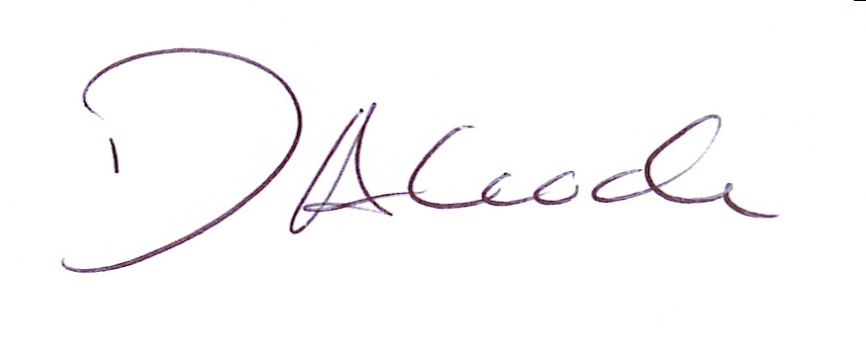
Darren Alcock
NATIONAL COMPETITIONS’ SECRETARY
darren.alcock@schoolsfa.com

